- nmap 192.168.1.1Scan common ports
Purpose: It identifies open entry points, running network services (such as web servers, SSH, or management interfaces), and potential security vulnerabilities on your device.
How it works: Nmap sends probe packets to the target IP address and analyzes the replies to classify each port as open, closed, or filtered.

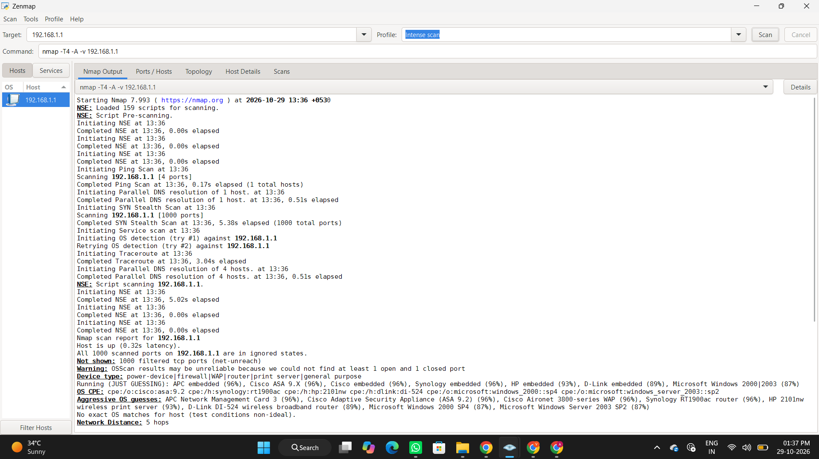
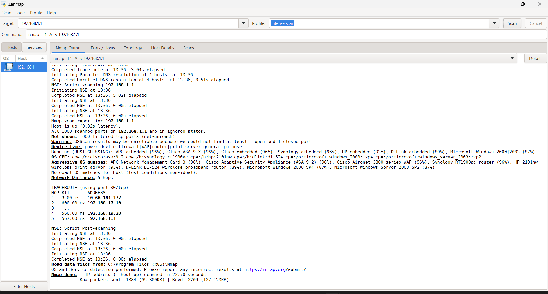

- nmap -sn 192.168.1.0/24 Discover live hosts
Purpose: Discovers active devices (live hosts) on the specified network without scanning their ports.
It helps identify which devices are currently reachable on the network.
How it works:It checks all IP addresses in the specified network range and displays active devices without scanning their ports.
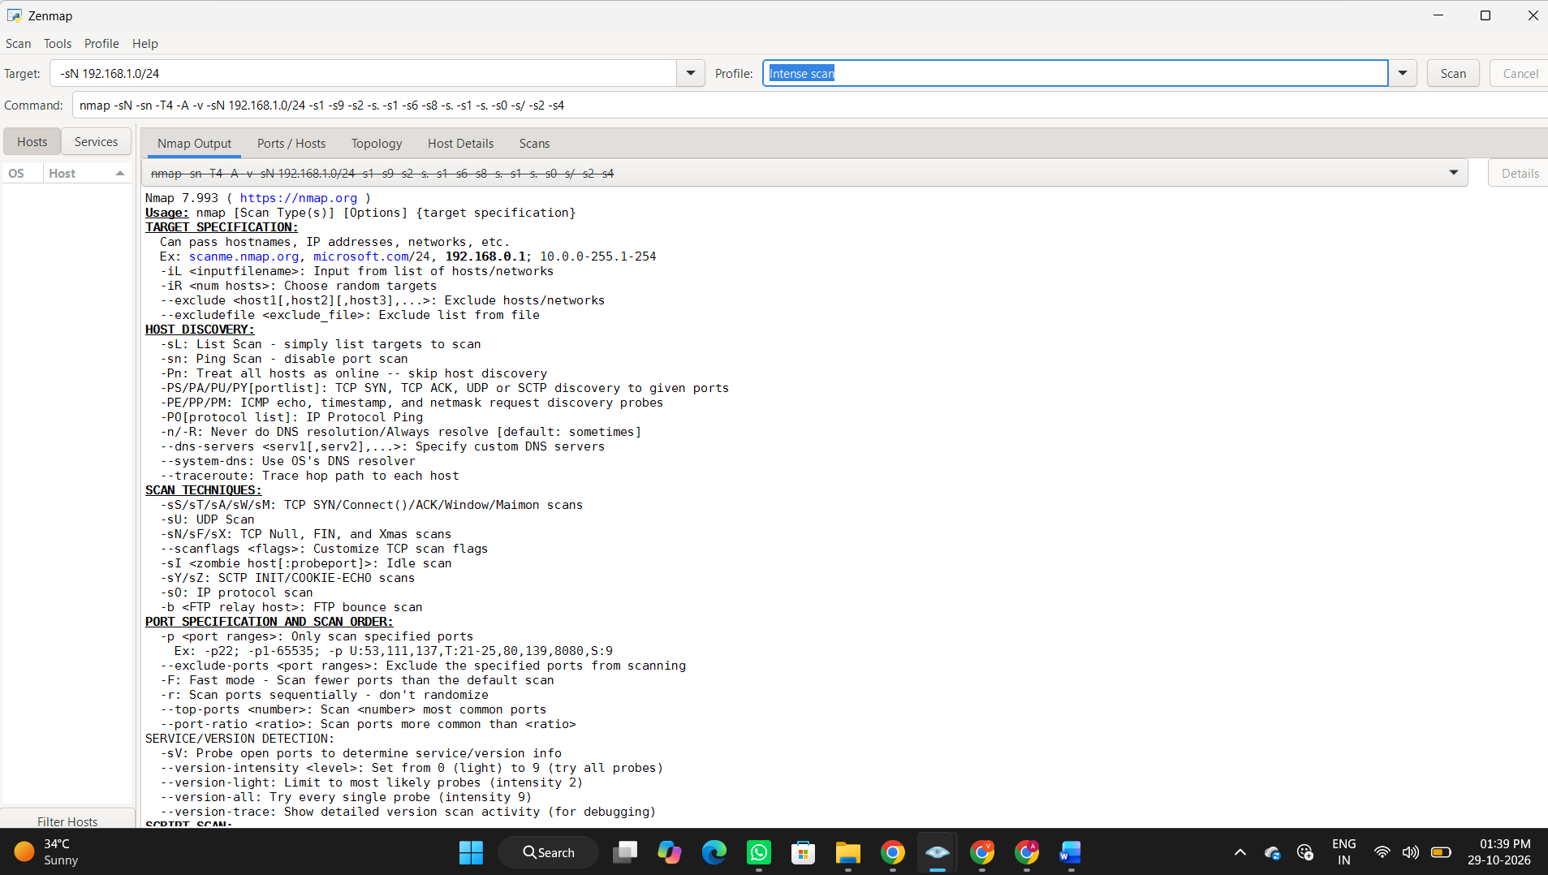

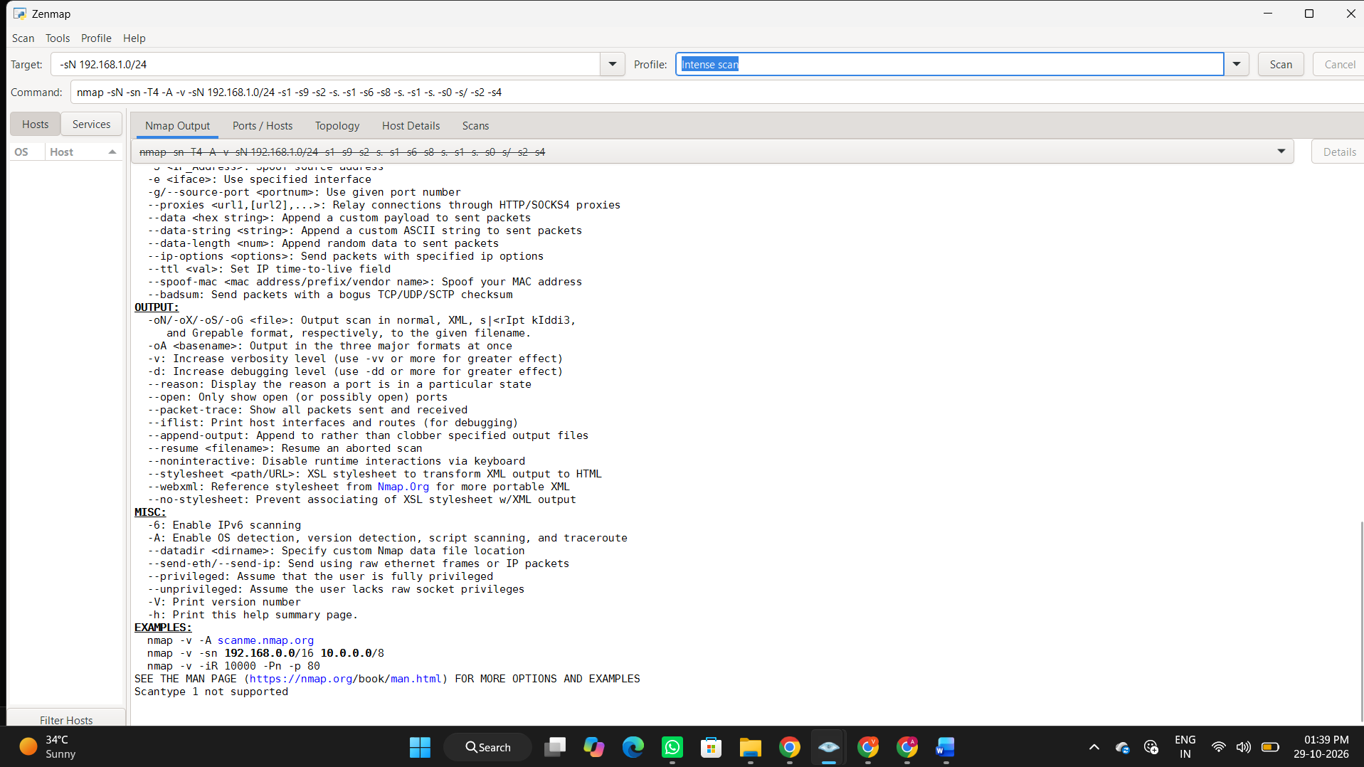

- nmap -sV 192.168.1.1 Detect service versions
Purpose: Identifies the services and their version numbers running on open ports of the target device.
How it works: Nmap sends probes to open ports and analyzes the responses to determine the service names and versions.

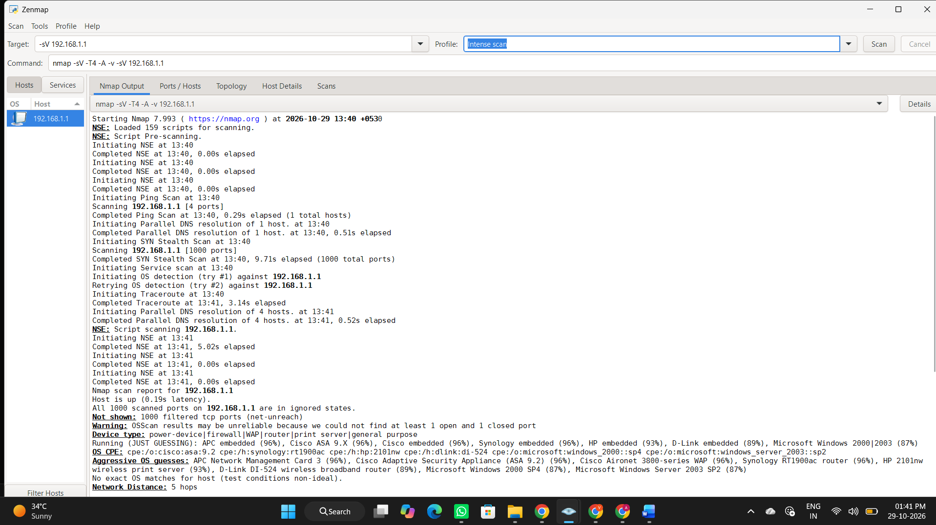
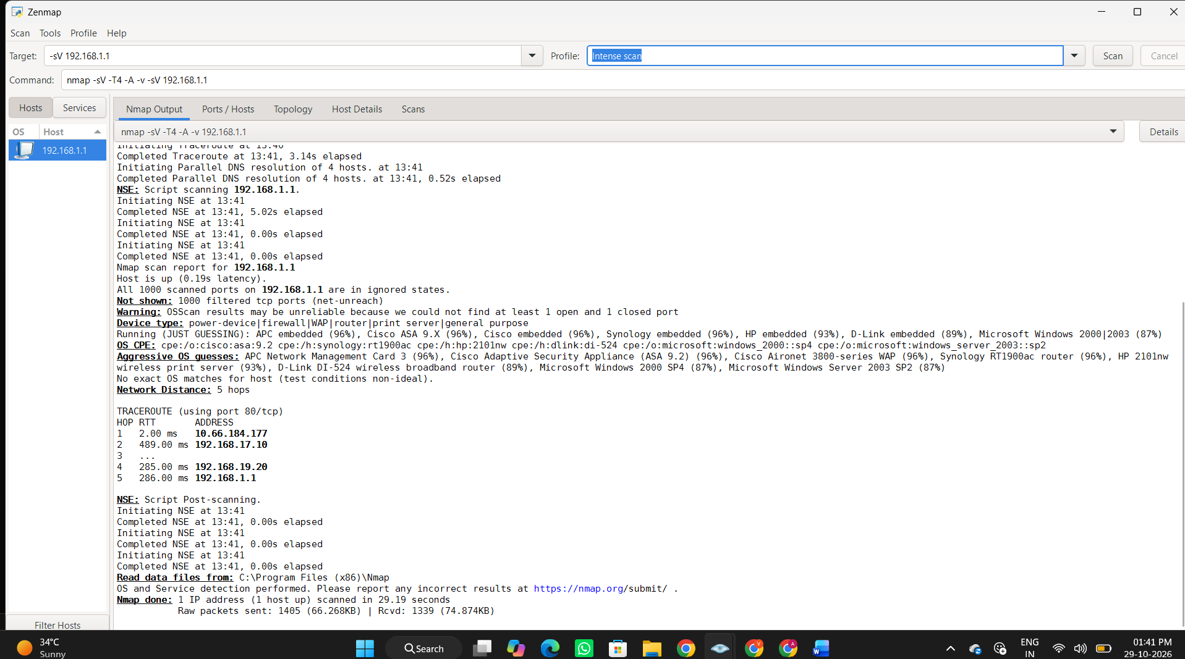

4) nmap -O 192.168.1.1 Identify the operating system
Purpose: Identifies the possible operating system of the target device, such as Windows or Linux.
How it works: Nmap analyzes the target's network responses and compares them with known operating system patterns to estimate the OS.

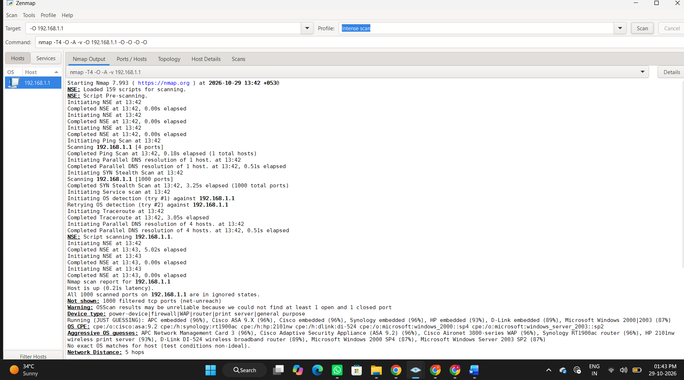
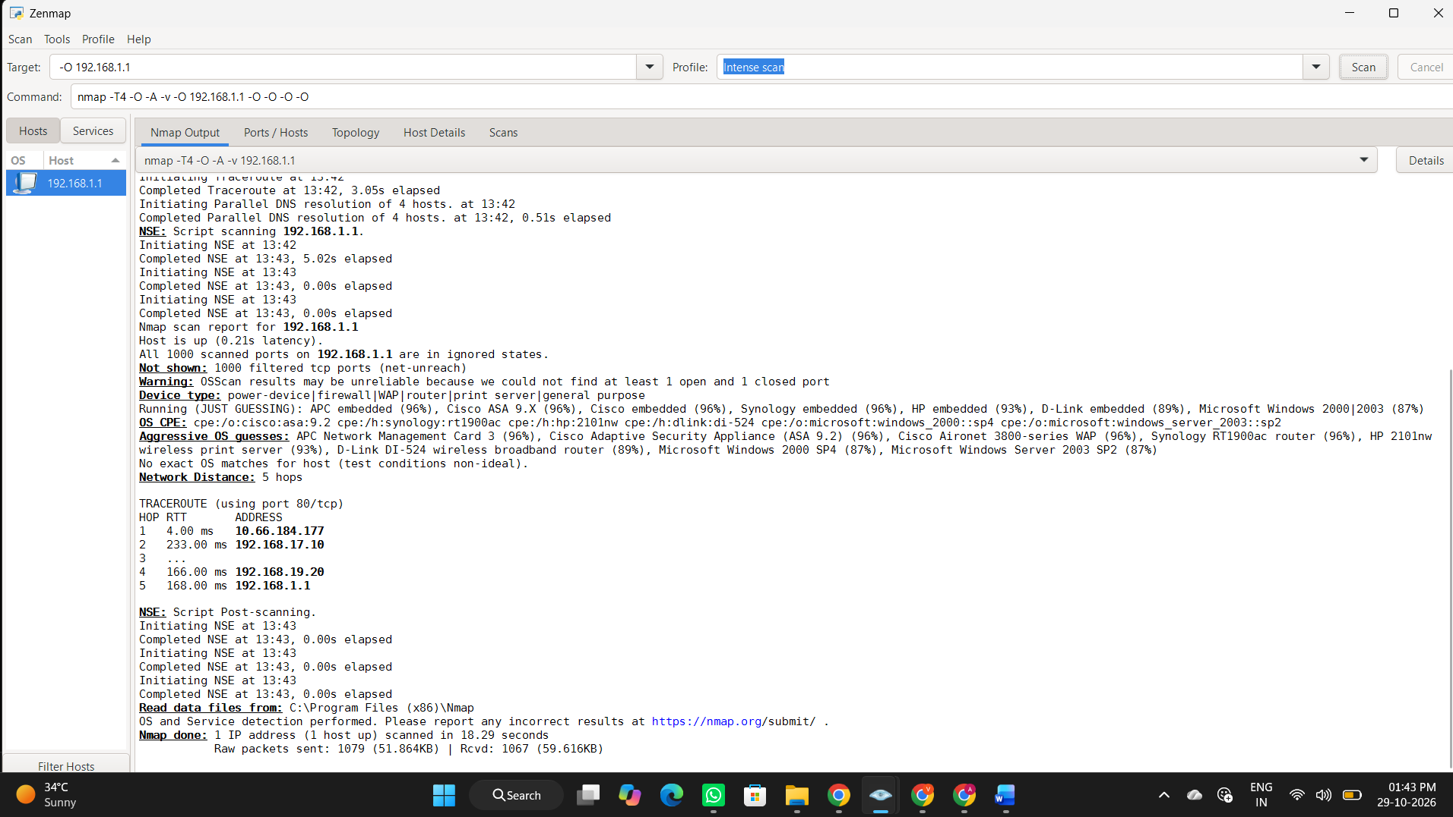

5)nmap -p 80,443 192.168.1.1 Scan specific ports
Purpose: Scans only the specified ports (80 and 443) on the target device to check whether they are open or closed.
How it works: Nmap sends probes to ports 80 (HTTP) and 443 (HTTPS) and reports their status.

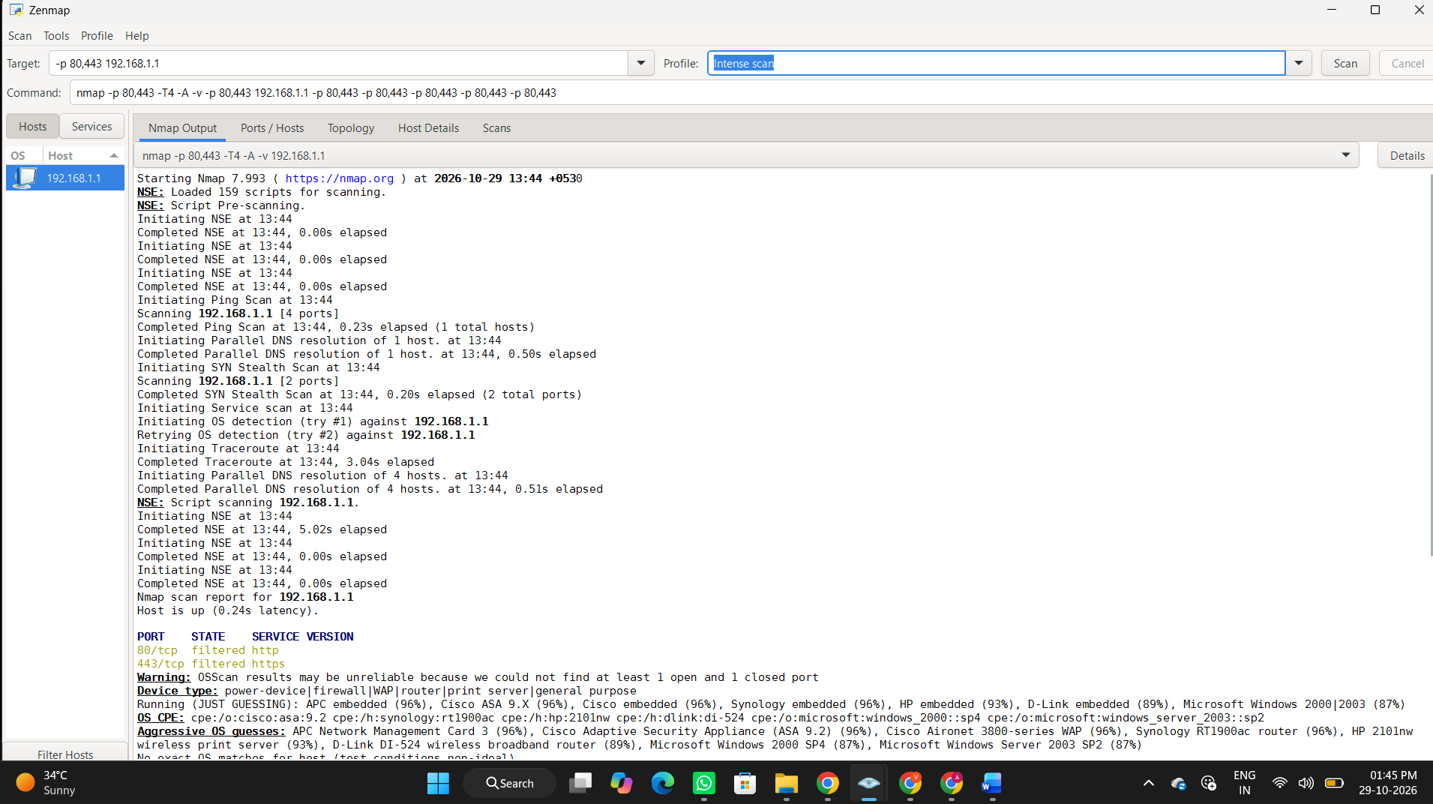
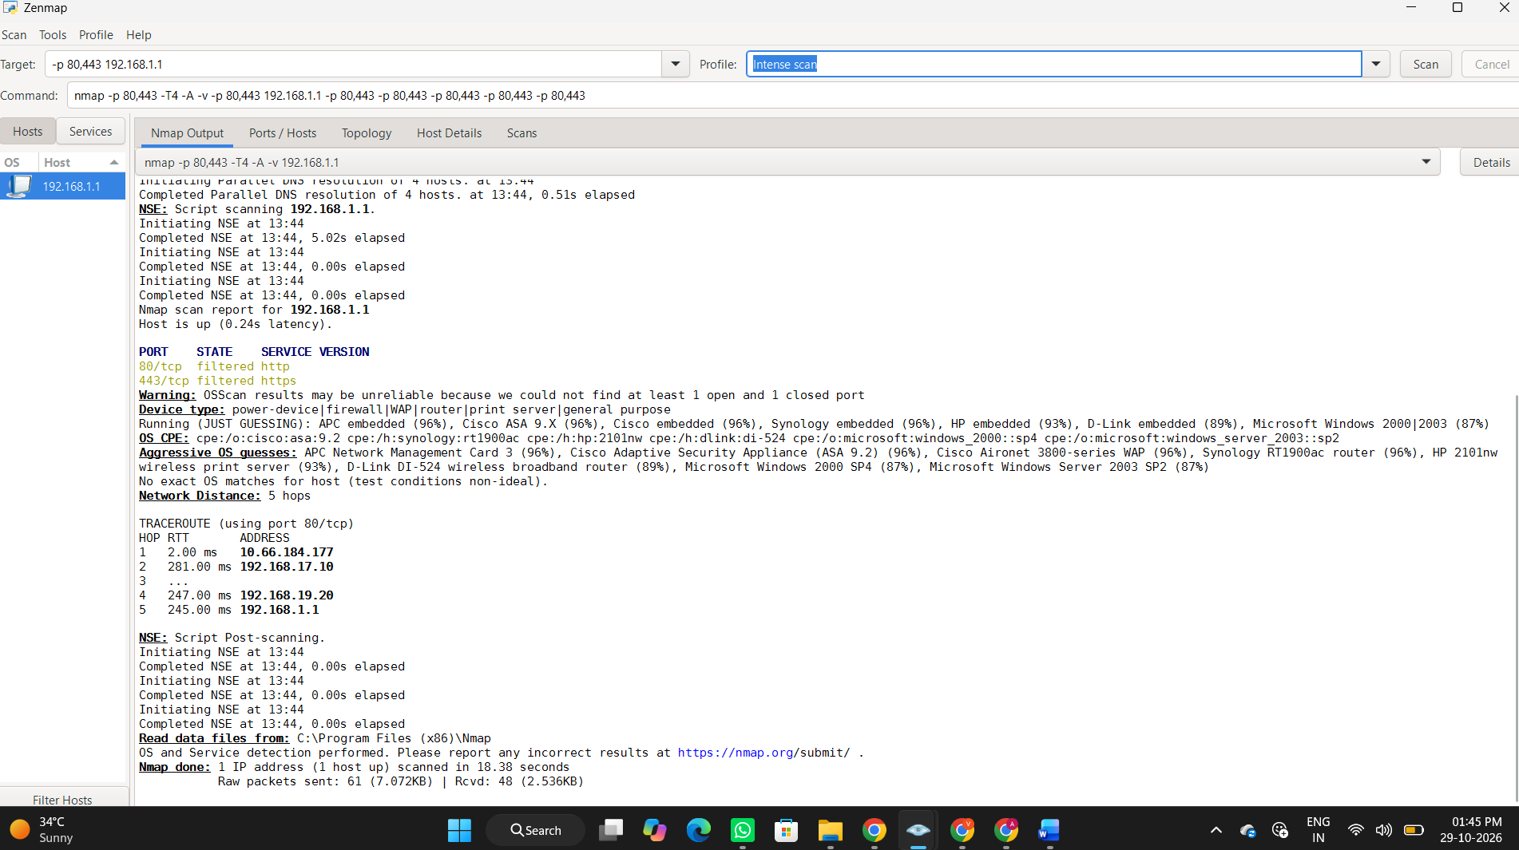

6) nmap -sC 192.168.1.1 Run default NSE scripts
Purpose: Runs default Nmap Scripting Engine (NSE) scripts to gather additional information about the target device and its services.
How it works: Nmap executes a set of default scripts to check for common service details and potential security issues on the target.

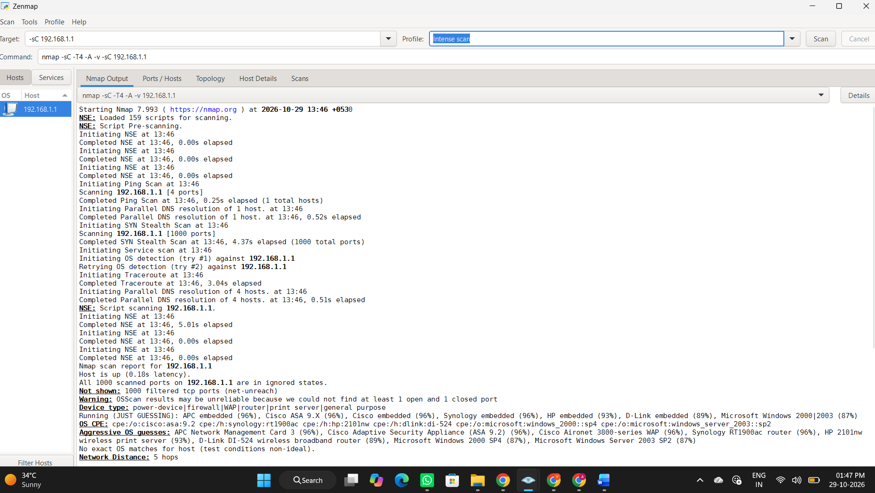
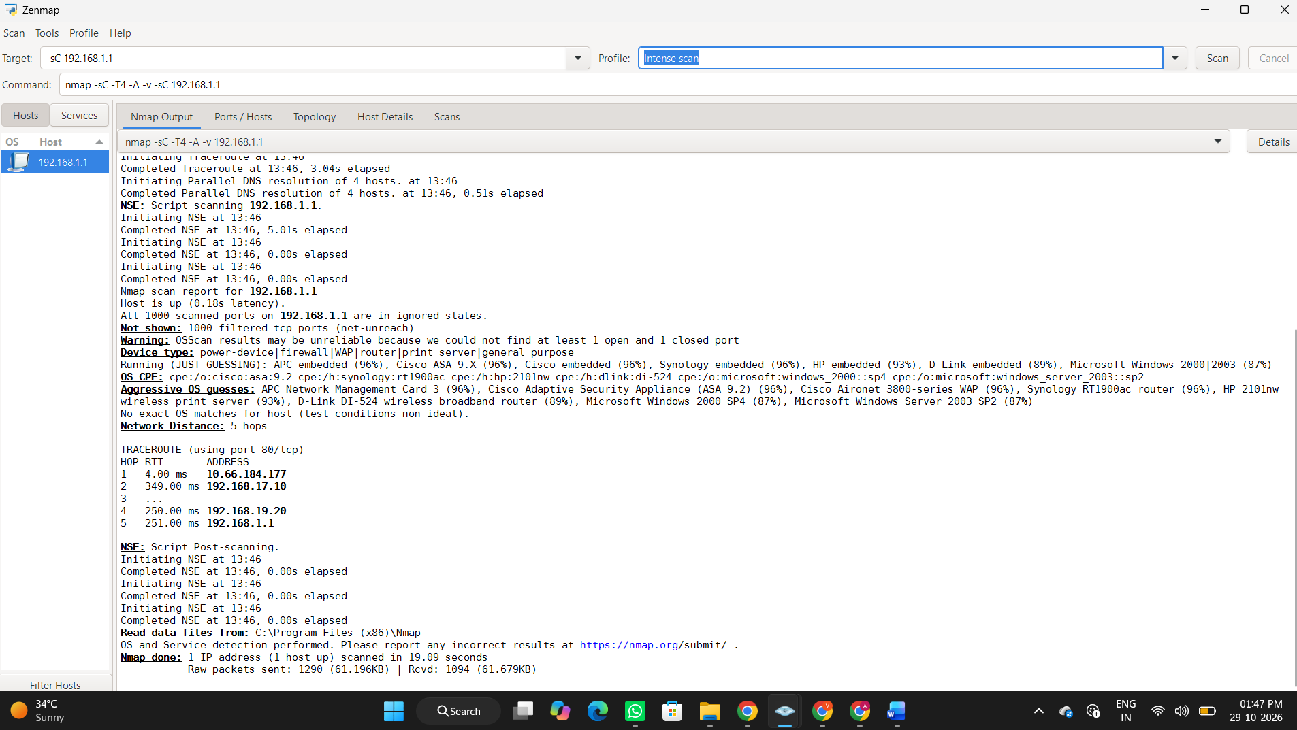

7) nmap -Pn 192.168.1.1 Skip host discovery
Purpose: Skips the host discovery process and scans the target device even if it does not respond to discovery probes.
How it works: Nmap assumes the target is online and proceeds directly to scanning its ports.

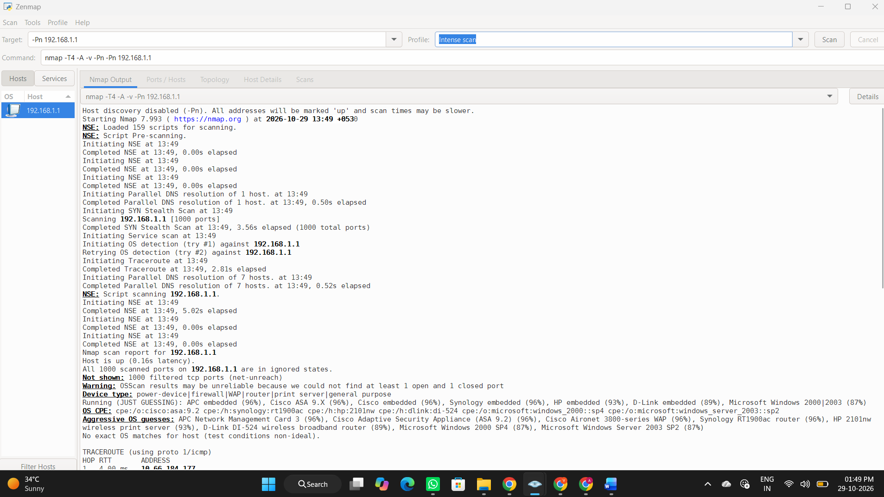
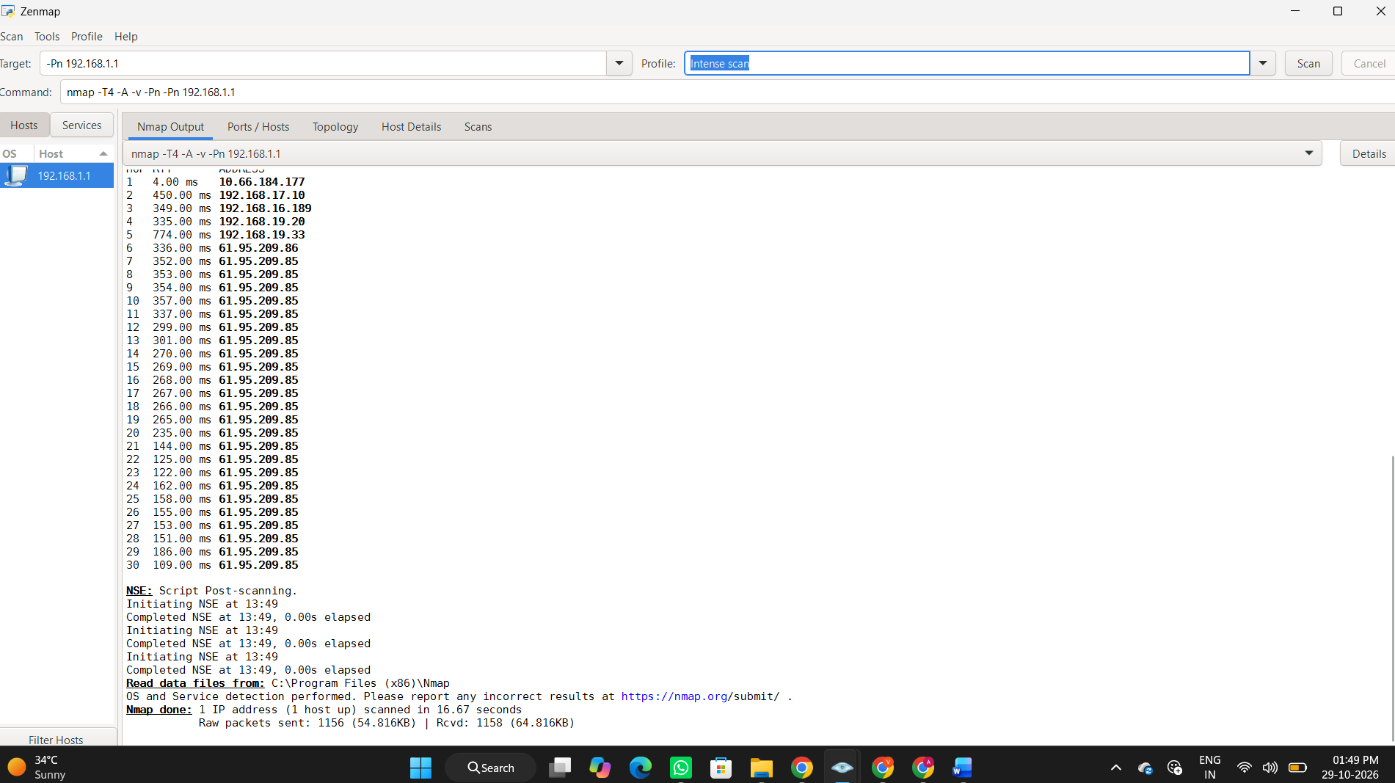

8) nmap -oN scan.txt 192.168.1.1 Save scan results to a file
Purpose: Saves the Nmap scan results in a text file named scan.txt for future reference and analysis.
How it works: Nmap performs the scan and stores the output in scan.txt in the current working directory.

